How to scan documents using the Office app on A mobile device
CREATION DATE: March 18, 2020

The purpose of this guide is to assist users with scanning and uploading documents using a mobile device.

Scanning and Emailing Documents:

Steps include:

First Log into your mobile device

Step 1: Click the Office App on your mobile device.

1: Click Office.
Figure 1

Step 2: Click the Plus Sign at the bottom of the Home screen.

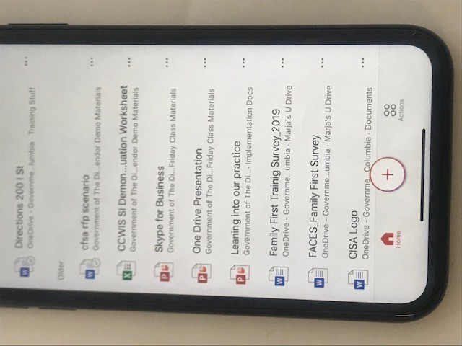
2: Click Plus Sign.
Figure 2

Step 3: Select the Documents Icon to access your documents (there are 3 options, select what is needed).

3: Click Documents Icon
Figure 3

Step 4: Select the format of the Document to be scanned (Word, Excel, Power Point) (you will get a notification for the camera to be accessed. Make sure your camera is on).

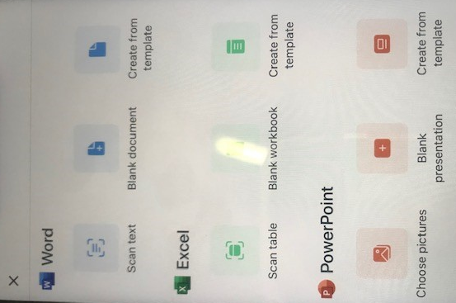
4: Select Document Format
Figure 4

Step 5: Click Button to take picture.

5: Click Button
Figure 5

Step 6: Click Done.

6: Click Done
Figure 6
NOTE:
You can tap the image to edit, crop or send if needed.
The document is also saved on the Home screen and can be accessed by clicking the back arrow at the top of the screen.
Step 7: Tap the Document to upload.

Step 8: Tap the Arrow on the top right of your screen to give the document a name, location, and/or keep a copy.
8: Tap Arrow
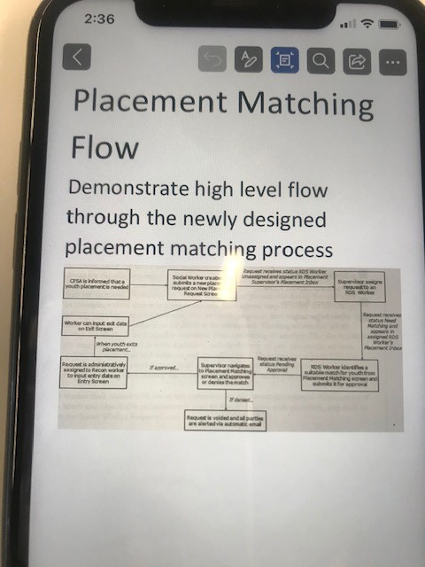
7: Tap Document
Figure 7

Step 9: Click Upload (The document is also saved on the Home screen and can be accessed by clicking the back arrow at the top of the screen).

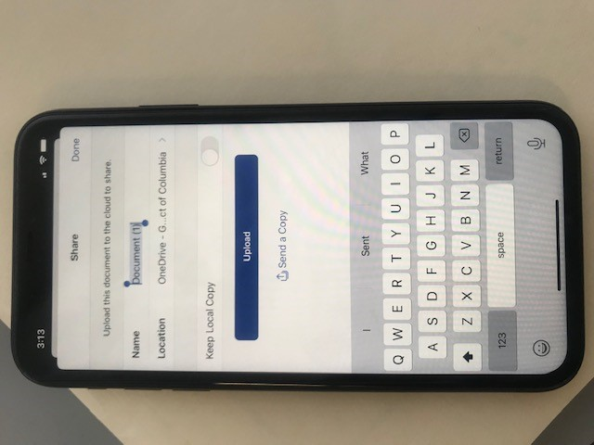
9: Tap Upload
Figure 8

Step 10: Tap the Document, using to tool bar at the top of the screen you can email the link.

10: Tap Arrow
Figure 9

Step 11: Enter Email Address

Step 12: Click Send

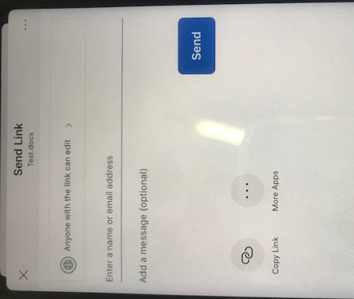
12: Click Send
11: Enter Email
Figure 10

