Is my family eligible for Project Connect?
If one or more of the items below are applicable to your family, your family may be eligible for Project Connect
Was substance use and/or exposure the reason for the removal? | Y ☐ N ☐
Does the parent, caregiver or youth’s substance use impede or is it a barrier to reunification or for the children to remain safely in the home? | Y ☐ N ☐
Does the parent’s substance use impact their ability to care for and provide a safe environment for their child? | Y ☐ N ☐
Is the parent/caregivers substance use a current concern or are there presenting concerns that lead you to believe the parent/caregiver is at high risk for relapse? | Y ☐ N ☐

Please indicate referral source:
ACEFS | ☐
CPS | ☐
In Home | ☐
Permanency | ☐
Private Provider:______________________________________________ | ☐

Referral Date: Enter date.
Section a. CFSA/ Private Provider Social Worker Information:
Social Worker Name:
Phone Number: | Email Address:
Social Worker Supervisor Name:
Phone Number: | Email Address:

Section B. Parent Information:
Parent Name:
Date of Birth: Enter date. | Phone Number:
Address: |  | Ward:
Parent Client ID Number: | Parent Case ID Number:

Section C. Child (ren) Information: Please use drop down boxes
Child’s Name | Date of Birth | Home Status  (current placement of child) | Date of Removal | Legal Status
1. | Enter date. | Choose an item. | Enter date. | Choose an item.
2. | Enter date. | Choose an item. | Enter date. | Choose an item.
3. | Enter date. | Choose an item. | Enter date. | Choose an item.
4. | Enter date. | Choose an item. | Enter date. | Choose an item.
5. | Enter date. | Choose an item. | Enter date. | Choose an item.

Section D. Goals and Barrier Information:

- Length of time family has been involved with CFSA and reason for involvement?

- What is the next scheduled court date?
Click here to enter a date.

- What is the permanency plan/goal?
Choose an item.

- What are the barriers and /or complicating factors that may result in removal?

Section E. Substance Abuse History:
Is substance use treatment in case plan? Y ☐ N ☐
Is Recovery Specialist involved: Y ☐ N ☐ | Name:
Has APRA assessment been completed? Y ☐ N ☐
If yes, what are the recommendations. Please explain below (if you have a copy of the assessment, please attach in lieu of writing narrative below)

Section G. Please include any additional information about the family and/or case below, which may be helpful.
(i.e. currently homeless, receiving in/out patient treatment etc.)

Approval:
Has CFSA Social Worker Supervisor Approved the Application: Y ☐ N ☐
Social Worker Signature:  _____________________________ | Date: Click here to enter a date.

Please include the following documents for all Project Connect Referrals:
- Project Connect Referral Form
- Background Information Summary (use attached form)
- Most Recent Investigation Summary
- Case Plan (if applicable)
- Court Date and Report (if applicable)
- Most recent snapshot/intake summary (if applicable)

Please complete and return Project Connect applications to cfsa.projectconnect@dc.gov

GOVERNMENT OF THE DISTRICT OF COLUMBIA
Child and Family Services Agency
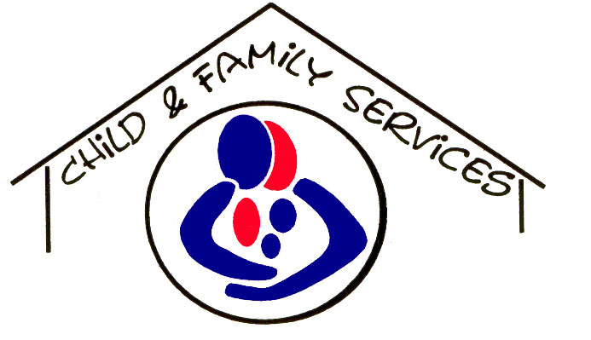

Substance Use/Exposure and Mental Health
Background Information

Referral Date: __________________

Client Name: _____________________________________

Please provide a detailed paragraph for each of the categories below.

Substance Abuse (current or previous use/exposure):

Mental Health:

________________________ ________________________
Name Name
Social Worker Social Work Supervisor
Division or Unit Division or Unit

