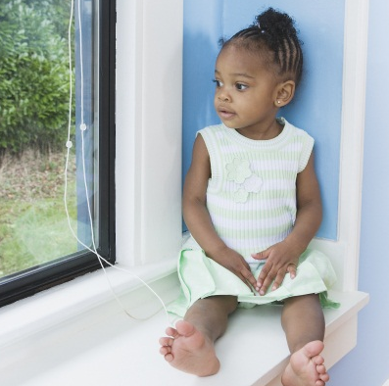 | Safe Families  for Children
Intent:
Parents in crisis can choose to have their children live in a safe, temporary home while they retain custody and work through their challenges.

Service Description:
When a crisis strikes, many of us rely on relatives and friends for support. But for some families, social isolation and poverty mean they don’t have these resources. Difficulties such as hospitalization, homelessness, incarceration, or unemployment can be debilitating. Children may face an increased risk of neglect, abuse, or removal from home.

During a temporary crisis, parents can get help from a Safe Families host home while retaining custody of their children. They can arrange for their children to stay in a trustworthy host home while they address issues. There is no charge for this service, and volunteers are not compensated financially for their participation.

The program provides:
- Short-term respite of a few days, weeks, or months, with the average hosting lasting 45 days.
- Host providers complete background clearances and training to ensure care will be safe, sufficient, and satisfactory.
- Wraparound services, including case management, mentoring (for children and parents), and assistance with resources.
- A commitment to have the child return to the family as soon as possible.

Who Qualifies:
Low- to moderate-risk families in crisis who are involved in a CFSA Child Protective Services investigation or family assessment or in an in-home case—or are involved with one of the Healthy Families/Thriving Communities Collaboratives

Examples include a parent/family without support from relatives or friends and:
- Experiencing short-term homelessness.
- Needing hospitalization (surgery, substance abuse treatment, etc.).
- Coping with job loss.
- Serving a short-term jail or prison sentence.
- Facing a temporary but overwhelming situation that makes caring for children difficult.

Provider/Period of Service:
Safe Families for Children, April 2015-April 2016

Referral Process:
Social worker completes the online referral form using the following steps:
- Go to www.dc127.org/referral,
- Under the section To Make a Referral, click on the Safe Families Preliminary Referral Form,
- Complete the referral form and email it to referral@dc127.org, and
- Call and speak with a Safe Families for Children staff member at 202-670-1145.

For More Information:
Stephanie Boyd, project assistant, CFSA Community Partnerships, stephanie.boyd@dc.gov; 202-724-7147

