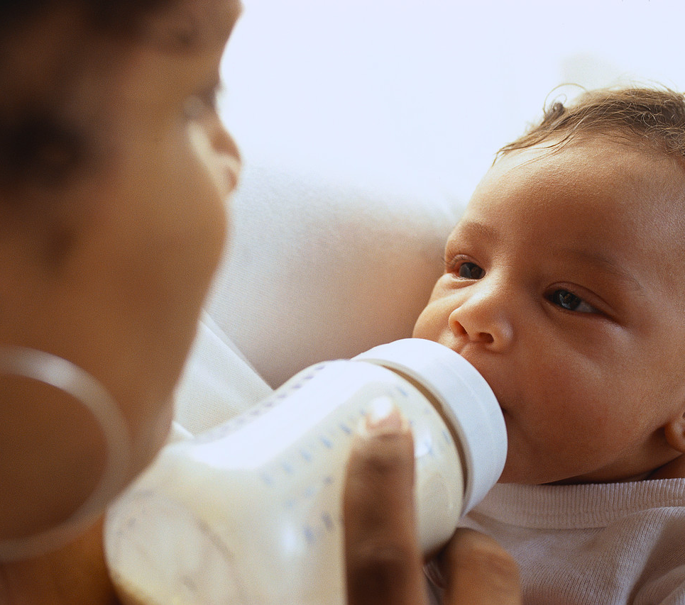 | Home Visitation  Program
Intent:
Expectant mothers and mothers feeling overburdened with infant care receive friendly coaching, parent education, and support in their homes as a preventive measure.

Service Description:
A team of family support workers and a community health nurse provide helping services and support to moms who may struggle with child-raising issues. Young expectant mothers or mothers with infants and/or other challenges get pre- and post-natal home visits from a friendly worker who provides child development information, parenting skills training, child-raising tips, and support. Case management services include:
- Family goal planning.
- Linkages to community resources.
- Physical and mental health education and support.
- Monthly family activities.

Services can continue through the child’s 5th birthday, if needed to promote safety.

Who Qualifies:
- Expectant mothers.
- Mothers with a child less than 3 months old.
Services are especially beneficial for mothers who fit these qualifications and also have children with special needs or have their own special needs or mental health concerns.

Provider/Period of Service:
Mary’s Center; August 2015-February 2016

Referral Process:
- Social worker completes referral form at: https://mindpetal.transactcentral.com/test
  - Type in your FACES.net username and password.
  - Click on Avoka OAuth.
  - Click on Forms Tab and Search for IV-E Waiver Early Intervention Services.
- CFSA Community Partnerships (CP) staff reviews referrals daily and refers eligible applicants to Mary’s Center within 48 hours.
- Within 24 to 48 hours of receiving the referral, Mary’s Center notifies CP of acceptance or denial.
- Within 72 hours, Mary’s Center provides CP staff and the referring social worker with the name of the family support worker they are assigning.
- Mary’s Center schedules a joint home visit to the family with the CFSA social worker.
- In case of a denial, Mary’s Center notifies CP staff of the reason within 72 hours. CP staff notifies the referring social worker and may suggest an alternate service based on the family’s characteristics.

For More Information:
Stephanie Boyd, project assistant, CFSA Community Partnerships, stephanie.boyd@dc.gov, 202-724-7147.

