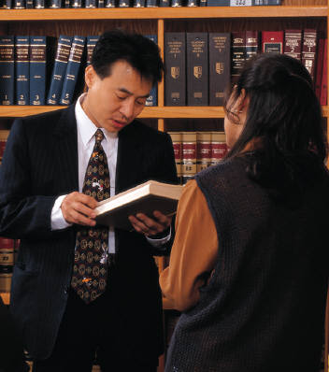 | Legal Services
Intent:
Families can get free legal help to address housing concerns, appeal denial of benefits, or resolve other barriers to reunification or overall well-being.

Service Description:
Free legal advice and/or possible representation regarding:
- Sub-standard living conditions, evictions, and other landlord-tenant issues.
- Denial of public benefits such as financial assistance, food stamps, medical assistance, disability payments, unemployment benefits, and more.
- Child custody, guardianship, divorce, paternity, and child support.
- Basic documents such as wills, advance health care directives, and powers of attorney.

Who Qualifies:
Families involved with CFSA or the Healthy Families/Thriving Communities Collaboratives

Provider/Period of Service:
Neighborhood Legal Services; April 2015-April 2016

Referral Process:
- Social worker completes and submits the online Neighborhood Legal Services Referral Form.
- CFSA Community Services forwards referral to Neighborhood Legal Services.
- Neighborhood Legal Services screens referrals and contacts both social worker and family about next steps.

For More Information:
Referrals from CFSA—Danita Bailey, executive assistant, CFSA Community Services, danita.bailey2@dc.gov, 202-724-7350

Referrals from Healthy Families/Thriving Communities Collaboratives—Jerra Mitchell, paralegal, Neighborhood Legal Services, JMitchell@nlsp.org, 202-678-2001

